ERTMS/ETCS – Class 1
System Requirements Specification
Chapter 5
Procedures
REF : | SUBSET-026-5
ISSUE : | 2.3.0
DATE : | 24/02/06

Company | Technical Approval | Management approval
ALCATEL

ALSTOM

ANSALDO SIGNAL

BOMBARDIER

INVENSYS RAIL

SIEMENS

Modification History
Issue Number  Date | Section Number | Modification / Description | Author / Editor
0.0.1 | Update of Class P document (version 1.1.1) on basis of Class 1 proposals |  | Kast, Hans
0.1.0  27.7.99 | Update according to decisions of review July 22/23 (Stockholm) |  | Kast, Hans
1.0.0  29.7.99 | Finalisation meeting in Stuttgart, 990729. |  | HE
1.2.0  990730 | Version number updated, Release version |  | HE
1.2.1  991209 | Updated according to proposals and comments from the ECSA/UNISIG database classified as "general" |  | Kast, Hans
1.3.0  991221 | Update according to decision of review meeting 15th/16th Dec. (Stockholm) |  | HK
2.0.0  991222 | Release version |  | HK
2.0.1  000919 | Debugging decisions (up to ...... ) included |  | HK
2.1.0  001017 | Update according to decisions of review on 10/11 Oct in Stuttgart |  | HK
2.2.0 | Version number | UNISIG release | SAB
2.2.2  020201 | Refer to document: SUBSET-026 Corrected Paragraphs, Issue 2.2.2 |  | HK
2.2.4 SG checked  28/05/04 | Including all CLRs agreed with the EEIG (see “List of CLRs agreed with EEIG for SRS v2.2.4” dated 28/05/04)  Affected clauses see change marks |  | H. Kast
2.2.5  21/01/05 | Incorporation of solution proposal for CLR 007 with EEIG users group comments  Corrections according to erratum list agreed in SG meeting 170105 |  | Hougardy A
2.2.6  31/01/05 | Including all current CR decisions (CR status "EEIG pending") |  | H. Kast
2.2.7  22/07/05 | Including all current CR decisions by the UNISIG SG  22/07/05 CR 126 added |  | H. Kast
2.2.8  06/12/05 | Including all new CR decisions made since SRS version 2.2.7 (i.e., since July '05) |  | H. Kast
2.2.9  24/02/06 | Including all CRs that are classified as "IN" as per SUBSET-108 version 1.0.0  Removal of all CRs that are not classified as "IN" as per SUBSET-108 version 1.0.0, with the exception of CRs 63,98,120,158,538 |  | H. Kast
2.3.0  24/02/06 | Release version |  | HK

Table of Contents
5.1 Modification History 2
5.2 Table of Contents 4
5.3 Introduction 6
5.3.1 Scope and Purpose 6
5.3.2 Definitions 6
5.4 Procedure Start of mission 8
5.4.1 Introduction 8
5.4.2 Status of data stored in the ERTMS/ETCS on-board equipment 8
5.4.3 Table of requirements for procedure. 8
5.4.4 State Diagram 16
5.4.5 Degraded Situations 19
5.5 Procedure End of Mission 20
5.5.1 General 20
5.5.2 Entry to Mode Considered as an End of Mission: 20
5.5.3 End of Mission Procedure 20
5.5.4 Degraded Situation 21
5.6 Shunting Initiated by Driver 22
5.6.1 General 22
5.6.2 State Chart 22
5.6.3 Explanatory Table for Entry into Shunting 23
5.6.4 Degraded Situation 23
5.7 Entry in Shunting with Order from Trackside 25
5.7.1 General Requirements 25
5.7.2 Shunting is requested for the current location (from modes different from Stand By and Post Trip) 25
5.7.3 Shunting is requested for a further location 25
5.7.4 Shunting from Stand By or Post Trip mode 26
5.7.5 State Diagram 27
5.8 Procedure Override EoA 28
5.8.1 Introduction 28
5.8.2 Selection of “Override” 29
5.8.3 Once the “Override EOA” procedure has been triggered 29
5.8.4 Re-activation of the transition to Trip mode 30
5.9 Procedure On-Sight 32
5.9.1 General Requirements 32
5.9.2 On Sight is requested for current location (from modes different from Stand By and Post Trip) 32
5.9.3 On Sight is requested for a further location 33
5.9.4 On Sight from Unfitted or STM mode 35
5.9.5 On Sight from Stand By or Post Trip mode 35
5.9.6 Exit of On Sight mode 36
5.9.7 State diagram 38
5.10 Level Transitions 39
5.10.1 General requirements 39
5.10.2 Requirements for mixed level 40
5.10.3 Specific Additional Requirements 41
5.10.4 Acknowledgement of the level transition 46
5.11 Procedure Train Trip 48
5.11.1 Introduction 48
5.11.2 State transition chart 48
5.11.3 Explanatory table for state transition chart Train Trip 50
5.11.4 Degraded Situations 52
5.12 Change of Train Orientation 53
5.12.1 Introduction 53
5.12.2 The driver uses the same engine 53
5.12.3 The driver leaves the engine to go to another one 53
5.13 Train Reversing 55
5.14 Joining / Splitting 56
5.14.1 Definitions 56
5.14.2 Procedure “Splitting” 56
5.14.3 Procedure “Joining” 56
5.15 RBC/RBC Handover 58
5.15.1 Principles 58
5.15.2 Case 1: Two communication sessions can be handled simultaneously 58
5.15.3 Case 2: Only one communication session can be handled 60
5.15.4 Degraded Situations 62

Introduction

Scope and Purpose

This document defines the procedures that are necessary for interoperability within the scope of UNISIG Class 1.

Each procedure is defined by a set of mandatory requirements and/or by a state transition chart (where convenient). All elements (States, events, transitions) of the state transition charts are explained within explanatory tables. The contents of these explanatory tables must be considered as mandatory requirements whenever expressed in such a way (e. g. "shall", "must never").

Most "standard" transitions as defined within Chapter 4 "Modes and transitions", are not shown in the procedures. Nevertheless they possess the higher priority and would lead to exit the procedures immediately in most cases (e. g. cut off power of on-board equipment, isolation of on-board equipment).

National operation rules (outside of ERTMS/ETCS) are also excluded, but may be applied by the railways in addition to the procedures as long as interoperability is retained.

Definitions

Procedures
A procedure defines the required reaction of the ERTMS/ETCS entities (subsystems and components) to either information exchanged between ERTMS/ETCS entities or events (triggered by external entities or internal events). The procedures focus on the required change in status and mode of the described ERTMS/ETCS entities.

Entities
The procedures define the required system behaviour on a context level, i. e. the entities that are used to define the procedures are for example: the on-board equipment, the trackside equipment (RBC/Balise), the driver.

States
States are situations of an ETCS subsystem with a specific set of available functions and a specific set of events that may start or terminate the state. A state remains active as long as the conditions to trigger the transition to a succeeding state are not completely satisfied.
Note 1: one mode of operation may include several states for the on-board equipment.
Note 2: A new state is only created, if the behaviour of the system differs from another one. Possession of information (e. g. location information) or not does not force branching in states.

Transitions
Transitions define the rules for passing from one state to another. A transition is triggered by a set of conditions which has to be fulfilled in a defined order or at the same time.

Procedure Start of mission

Introduction

The driver may have to start a mission:
- Once the train is awake, OR
- Once shunting movements are finished, OR
- Once a mission is ended, OR
- Once a slave engine becomes a leading engine.

The common point of all these situations is that the ERTMS/ETCS on-board is in Stand-By mode, but the Start of Mission will be different, since some data may be already stored on-board, depending on the previous situation.

Once the ERTMS/ETCS on-board equipment is in Stand-By mode, the start of mission is not the only possibility, the engine may be remote controlled (sleeping).

Status of data stored in the ERTMS/ETCS on-board equipment

At the beginning of the Start of Mission procedure, the data required may be in one of three states:
- “valid” (the stored value is known to be correct)
- “Invalid” (the stored value may be wrong)
- “Unknown”

This refers to the following data: Driver ID, ERTMS/ETCS level, RBC ID/phone number, Train Data, Train Position (i.e., LRBG, distance from LRBG, train orientation).

Note 1: The status of data in relation to the previous and the actual mode is described in chapter 4, section "What happens to stored information when entering a mode".

Note 2: The change of status of data in course of the procedure is shown in the table in section 5.4.3.3.

Table of requirements for procedure.

The ID numbers in the table refer to the representation of the procedure in form of a flow chart in section 5.4.4.

Procedure
ID in Flow Chart | Requirements
S0 | The Start of Mission procedure shall be engaged when the ERTMS/ETCS on-board equipment is in Stand-By mode with a desk open.
S1 | Depending on the status of the Driver-ID, the ERTMS/ETCS on-board equipment shall request the driver to enter the Driver-ID (if the Driver-ID is unknown) or shall request the driver to revalidate or re-enter the Driver-ID (if the Driver-ID is invalid).  Once the Driver-ID is entered or revalidated (E1), the process shall go to D1
D1 | If, according to the stored information (status "valid" or "invalid"), the level is 2 or 3 with a RBC-ID and phone number , then the process shall go to A31, otherwise, it shall go to D2
D2 | If the stored position is valid, the process shall go to S10  If the stored position is invalid or unknown, the process shall go to S2
S2 | If the status of the Level data is "unknown", the ERTMS/ETCS on-board equipment shall request the driver to enter it.  If the status of the Level data is "invalid", the ERTMS/ETCS on-board equipment shall request the driver to re-validate or re-enter the ERTMS/ETCS level.  If the entered / re-validated level is 2 or 3, the process shall go to S3  If the entered / re-validated level is 0 or 1, the process shall go to S10  If the entered / re-validated level is STM, the process shall go to A1
S3 | The ERTMS/ETCS on-board equipment shall offer the possibility to the driver to re-enter the Radio Network ID.  If the status of the RBC-ID/phone number is "unknown", the ERTMS/ETCS on-board equipment shall request the driver to enter it.  If the status of the RBC-ID/phone number is "invalid", the ERTMS/ETCS on-board equipment shall request the driver to re-validate or re-enter it.  Once data is validated (E5), the process shall go to A31
A1 | When the validated level is level STM, the ERTMS/ETCS on-board equipment shall request the driver to select the STM corresponding to his mission.  Once the STM is selected (E6), the process shall go to S10
S10 | The ERTMS/ETCS on-board equipment shall offer the possibility to the driver to select SH, NL, to select Train Data Entry, to select “change of level” or to select “override” (only if validated Train Data is available).  - If the driver selects SH (E12), the continuation of the procedure is the same as for the procedure “Shunting initiated by the driver”. If in any further step, the driver selects SH, then the start of mission shall be stopped and the on-board switches to SH mode (if the other conditions to switch to SH are fulfilled).  If, in level 2 or 3, the RBC rejects the request for Shunting (E13), the on-board equipment shall await another selection by the driver.  - If the driver selects NL (E10) then the ERTMS/ETCS on-board equipment shall immediately switch to Non Leading mode (refer to SRS chapter 4, transition between modes: transition [46]). The mission starts in NL mode (if level is 2 or 3, the ERTMS/ETCS on-board equipment also reports the change of mode to the RBC). If in any further step, the driver selects NL, then the start of mission shall be stopped and the on-board switch to NL mode. If NL mode had been requested and no session is open, no system reaction shall be required except for a message the driver indicating that no track condition information will be received.  - If the driver selects Train Data Entry (E11), the procedure shall go to S12  - If the driver selects “Change of level” (E17), the procedure shall go to S2  - If the driver selects “Override” (E15), the procedure “Override EoA” shall be entered
S12 | For each individual Train Data (refer to 3.18.3.2), the following shall apply:  - If the only source of Train Data is the driver, the ERTMS/ETCS on-board equipment shall request the driver to enter or re-validate this data  - If there is another source of Train Data (i.e., the train interface, or Train Data already stored on-board), and if the status of the Train Data received from this source is "invalid", the ERTMS/ETCS on-board equipment shall request the driver to validate this Train Data. The driver shall have the possibility to modify data before validating it.  The ERTMS/ETCS on-board equipment shall request the driver to enter and validate the additionally needed STM data.  Once Train Data and (if required) additional STM data is stored and validated (E16), the process shall go to D10
D10 | When the validated level is 2/3, the process shall go to D11  When the validated level is 0,1 or STM, the process shall go to S20
D11 | When the session is open, the process shall go to S11, otherwise it shall go to S10
S11 | The ERTMS/ETCS on-board equipment shall send Train Data to the RBC.  When the RBC acknowledges Train Data (E14), then the ERTMS/ETCS onboard equipment shall go to the step S20.
S20 | The ERTMS/ETCS on-board equipment shall offer the possibility to the driver to select “Start”  - When the validated level is STM and the driver selects "start" (E20), the process shall go to S22  - When the validated level is 0 and the driver selects "start" (E21), the process shall go to S23  - When the validated level is 1 and the driver selects "start" (E22), the process shall go to S24  - When the validated level is 2 or 3 and the driver selects "start" (E24), the process shall go to S21
S21 | The ERTMS/ETCS on-board equipment shall send an MA request to the RBC and wait.  If an SR authorisation is received from RBC (E26), the process shall go to S24  If an MA allowing OS/SH is received from RBC (E27), the process shall go to S25  If an MA allowing FS is received from RBC (E29), the mission starts in Full Supervision mode (refer to SRS chapter 4, transitions between modes: transition from SB to FS)
S22 | The ERTMS/ETCS on-board equipment shall request an acknowledgement from the driver for running under supervision of the selected STM mode. When the driver acknowledges (E30) , the mission starts in STM European mode (if the selected STM is of “European” type) or in STM National mode (if the active STM is of “national” type) (refer to SRS chapter 4, transitions between modes, also Subset 035).
S23 | The ERTMS/ETCS on-board equipment shall require an acknowledgement from the driver for running in Unfitted mode. When the driver acknowledges (E31), the mission starts in Unfitted mode (refer to SRS chapter 4, transitions between modes: transition from SB to UN)
S24 | The ERTMS/ETCS on-board equipment shall require an acknowledgement from the driver for running in Staff Responsible mode. When the driver acknowledges (E32), the mission starts in SR mode (refer to SRS chapter 4, transitions between modes: transition from SB to SR)
S25 | The ERTMS/ETCS on-board equipment shall require an acknowledgement from the driver for running in On Sight/Shunting mode. When the driver acknowledges (E33), the mission starts in On Sight/Shunting mode (refer to SRS chapter 4, transitions between modes: transition from SB to OS or SH)
A31 | The ERTMS/ETCS on-board equipment shall open the session with the RBC.  If driver has entered a new Radio Network ID (see S3), registration of Mobile Terminal(s) to this new Radio Network shall be ordered prior to the establishment of session with RBC.
D31 | If the opening of the session is successful, the process shall go to D32  If the opening of the session has failed, the process shall go to A32
A32 | The driver shall be informed when the on-board equipment fails to open a radio session.  Opening of a radio session has failed if  - No connection to the RBC can be established (see section 3.5.3.7) OR  - The ERTMS/ETCS on-board equipment, based on the system configuration reported by the RBC, decides that compatibility is not ensured and terminates the communication session  This condition leads to S10 (The driver has to unlock the situation to continue e.g. selection of new level).
D32 | If the stored position is valid, the process shall go to A33  If the stored position is invalid, the process shall go to A34
A33 | If the train position data stored in the on-board equipment is of status “valid”, the train position, marked as “valid” shall be transmitted to the RBC via the "SoM position report" message.  This condition leads to S10.
A34 | If the train position data stored in the on-board equipment is of status “invalid” or "unknown", the train position, marked as “invalid” or "unknown" shall be transmitted to the RBC via the "SoM position report" message.  The process shall then go to D33
D33 | When the position report marked as "invalid" is received by the RBC, this latter shall check whether it can validate this position report.  If the position report can be validated by the RBC, the process shall go to A35  Otherwise, if the position report was marked "unknown", or the "invalid" position report cannot be validated by the RBC, the process shall go to D22  Note: How the RBC is able to validate the position report is a national issue, out of the scope for this specification
A35 | The RBC shall inform the ERTMS/ETCS onboard equipment that the reported position is valid.  When this message is received by the ERTMS/ETCS on-board equipment, the status of the position shall be set to "valid"  The procedure shall go to S10.
D22 | If the reported train position is "unknown", or the RBC is not able to confirm a reported "invalid" position, the RBC shall nevertheless decide whether it accepts the train or not.  If yes, the process shall go to A23  If no, the process shall go to A38  Note: How the RBC assumes responsibility for the train is a national issue, out of the scope for this specification
A23 | The RBC shall inform the ERTMS/ETCS on-board equipment that it accepts the train although the on-board has no "valid" position information.
A24 | When the ERTMS/ETCS on-board equipment is informed that the train is accepted without valid position data, it shall delete the train position data (new status: “unknown”)  This condition leads to S10.
A38 | The RBC shall inform the ERTMS/ETCS on-board equipment that it rejects the train
A39 | When the ERTMS/ETCS on-board equipment is informed that the train is rejected, it shall delete the train position data (new status: “unknown”) and shall terminate the session with the RBC  The process shall then go to A40
A40 | The ERTMS/ETCS on-board equipment shall inform the driver that the train is rejected  This condition leads to S10 (the driver has to unlock the situation to continue e.g. selection of new level).

Status of On-board Variables Affected by Start of Mission Procedure

 | State of On-board Variables
 | ERTMS/ETCS Level |  |  | RBC ID/Phone Number |  |  | Train position  data |  |  | Driver ID |  |  | Train Data
Transition conditions | Un-known | Invalid | Valid | Un-known | Invalid | Valid | Un- known | Invalid | Valid | Un- known | Invalid | Valid | Un- known | Invalid | Valid
Following S1 : Driver has entered driver ID |  |  |  |  |  |  |  |  |  | ●
Following S1 : Driver has re-validated/ re-entered driver ID |  |  |  |  |  |  |  |  |  |  | ●
Following S2 : driver has entered level | ●
Following S2 : driver has re-validated/ re-entered level |  | ●
Following S3 : driver has entered RBC ID/Phone Number |  |  |  | ●
Following S3: driver has re-validated/re-entered RBC ID/Phone Number |  |  |  |  | ●
Following D31: session has been successfully opened |  | ● |  |  | ●
A35 : RBC reports to On-board : position valid |  |  |  |  |  |  |  | ●
A24 : On-board deletes stored position data |  |  |  |  |  |  |  | ●
A39 : On-board terminates session, deletes stored position data |  |  |  |  |  |  |  | ●
Following S12: Train Data have been entered |  |  |  |  |  |  |  |  |  |  |  |  | ●
Following S12: Driver has (re-) validatedTrain Data |  |  |  |  |  |  |  |  |  |  |  |  |  | ●
Following S10: Driver has selected change of level |  |  | ● |  |  | ●

State Diagram

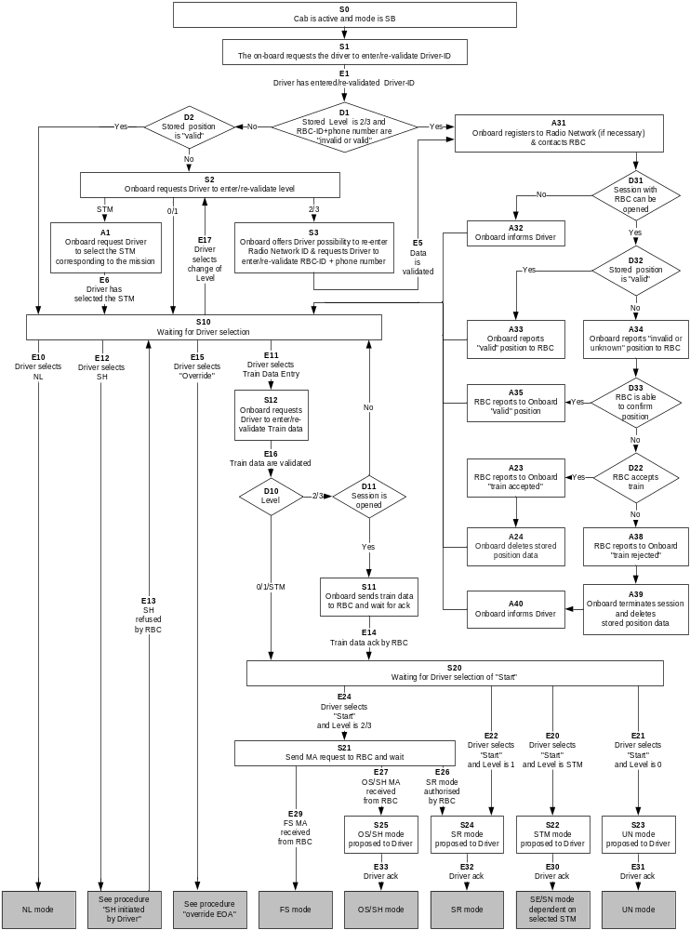

Degraded Situations

Nominally, accidental loss of an already open session (that can occur at any step) has not been taken into account for the design of the flowcharts. However, should such a fault occurs above D11 the nominal procedure applies (refer to D11 in flowchart). On the other hand, if it occurs in any step further than D11, the process shall go to S10.

For degraded situation if Train data is available (i.e. step S12 has already been passed) the driver may select Override (see E15 as example in flowchart) and the process shall go to the procedure “Override EoA”

If the driver makes a mistake during data entry regarding

“Driver-ID”: selection to re-enter the Driver-ID” shall only be possible at S10 and S20

“Train Data”: selection to modify Train data shall only be possible at S20, then the process shall go to S12.

“Level”: selection to change the Level shall only be possible at S10. Then the process shall go to S2

Procedure End of Mission

General

End of mission refers to the situation where the trackside stops to authorise the movement of a unit. End of mission is initiated by the ERTMS/ETCS on-board equipment when entering specific modes (see below).

Entry to Mode Considered as an End of Mission:

Stand-By mode

From FS, OS, UN, NL, or SR, RV mode, the entry of the ERTMS/ETCS on-board equipment into the Stand-by mode is considered as an End of Mission

From SE/SN modes (STM level), the conditions to end the mission depend on the STM.

Sleeping mode

The entry of the ERTMS/ETCS on-board equipment into the Sleeping mode is considered as an End of Mission.

Note: The transition to Sleeping mode is always made from the Stand-By mode (refer to chapter 4, transition between modes). If the end of mission has been already executed in Stand-by mode no further end of mission is required.

Shunting mode

The entry of the ERTMS/ETCS on-board equipment into the Shunting mode, from FS, OS, SR, PT or UN mode, is considered as an End of Mission.

End of Mission Procedure

The procedure comprises the following steps

Step 1 - MA, Track Description Data and Train Data may be deleted (mode dependent, see Chapter 4, section "What happens to stored information when Entering a Mode")

If the ERTMS/ETCS level is 0 or 1: End of procedure

If the ERTMS/ETCS level is 2 or 3:
Step 2 - The end of mission shall be reported to the RBC by means of the message “End of Mission”.
Step 3 - The RBC shall request to terminate the communication session.
Step 4 - The ERTMS/ETCS on-board equipment shall terminate the communication session
End of procedure

Note: For the termination of the communication session refer to chapter 3, Management of Radio Communication.

If the ERTMS/ETCS level is STM: End of Mission is individual to the STM, and executed by the STM.

Degraded Situation

Level 2,3 : In case a communication session is open and no request to terminate the session is received from the RBC the end of mission message shall be repeated a defined number of times (see appendix to chapter 3, List of Fixed Value Data). If not successful the ERTMS/ETCS onboard equipment shall terminate the session.

Level 2,3 : In case no communication session is open, no communication session shall be established to report the end of mission.

Shunting Initiated by Driver

General

The procedure describes the selection of shunting by the driver from FS, OS, SR, PT and UN mode.

Note: Entry from STAND BY mode is included in the procedure "Start of mission".

State Chart
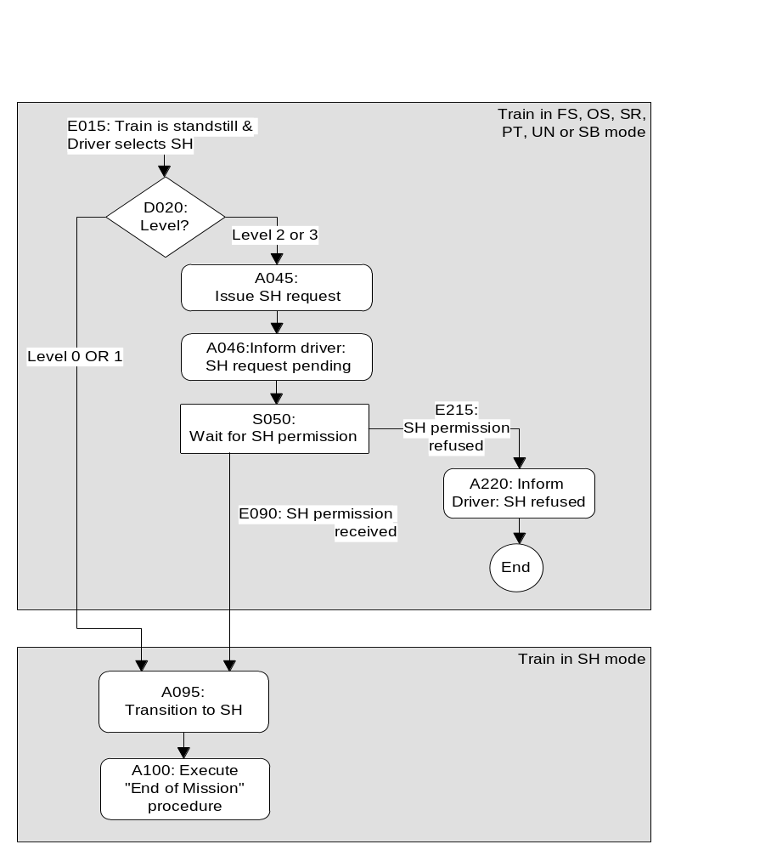

Figure 1. State diagram for Entry into Shunting

Explanatory Table for Entry into Shunting
# | Description | Level
E015 | The driver selects "Shunting" while the train is at standstill and the ERTMS/ETCS on-board equipment is in one of the following modes:  - FS  - OS  - SR  - UN  - PT  - SB (if necessary preconditions are fulfilled: Driver ID known, Level known, ... see procedure "Start of mission".). | All
D020 | What is the current ETCS Level of operation? | All
A045 | The ERTMS/ETCS on-board equipment sends the “Request for Shunting” message to the RBC together with a position report (with special value “position unknown” if the position is not known) | 2,3
A046 | The on-board equipment indicates on the driver MMI, that SH permission request to the RBC in pending | 2,3
S050 | The ERTMS/ETCS on-board equipment awaits SH permission. | 2,3
E090 | The ERTMS/ETCS on-board equipment receives the SH permission from the RBC. | 2,3
A095 | The transition to SH mode shall be made. | All
A095 | The mode change shall be reported to the RBC. | 2,3
A100 | The “End of Mission" procedure is executed on entering SH mode | All
E215 | The ERTMS/ETCS on-board equipment receives the information from the RBC "SH refused". | 2,3
A220 | An indication shall be given on the driver MMI, that SH permission was refused by the RBC. | 2,3

Degraded Situation

ERTMS/ETCS level 2 or 3: no answer to Shunting request is received from the RBC

In case a communication session is open and no reply is received from the RBC the SH request message shall be repeated a defined number of times (see appendix to chapter 3, List of Fixed Value Data). If not successful the ERTMS/ETCS onboard equipment shall terminate the session and inform the driver.

In case no communication session is open when the SH request is to be sent no communication session shall be established to send the request and the driver informed.

If no authorisation for SH mode can be received from the RBC, refer to procedure “Override EoA”.

Entry in Shunting with Order from Trackside

General Requirements

This procedure is used to allow the entry of a train into a shunting area.

Note: The shunting area, possibly including a “safety envelope”, can be already occupied by shunting units, not controlled by the trackside. It is therefore possible that the train shall enter into the shunting area in OS mode. The switch to OS is performed according to the relevant procedure.

The order to switch to SH mode shall be given by means of a mode profile and possibly, a list of balises, which the train can pass when the ERTMS/ETCS on-board equipment is in shunting mode.

The switch to shunting, if the transition to shunting was ordered by trackside, requires a driver acknowledgement, according to the specifications below.

When the ERTMS/ETCS on-board equipment has switched to Shunting mode, End of Mission, according to chapter 5.5.2.3, is performed.

Shunting is requested for the current location (from modes different from Stand By and Post Trip)

In a level 1 area, or at the border from a level 0 to a level 1 area, the beginning of the shunting area can be the location where a balise group is installed. In level 2/3 it is possible to send an ERTMS/ETCS on-board equipment the order to switch to shunting at the current location.

Shunting is requested for the current location means that, according to the mode profile received the max safe front end of the train is at or in advance of the location for which switching to SH mode is requested.

The ERTMS/ETCS on-board equipment shall switch immediately to SH mode and a request for acknowledgement shall be displayed to the driver (refer to SRS chapter 4, transitions between modes).

If the driver does not acknowledge within 5 sec after the change to SH mode, the service brake command shall be triggered. The command shall be released as soon as the driver acknowledges (unless the command was triggered also for other reasons).

Shunting is requested for a further location

An order to switch to SH at a further location can be sent
- in a level 1 area by a balise group,
- in a level 2 or 3 area by the RBC.

A request for acknowledgement shall be displayed to the driver, when the following two conditions are fulfilled:
- the distance between the estimated front end of the train and the beginning of shunting area is shorter than a value, contained in the mode profile
- the speed is lower than the Shunting mode permitted speed (National Value, or value given in the mode profile)

Once the request for acknowledgement is displayed, it shall not be taken back, even if the above conditions are no more fulfilled (e.g., the train accelerates).

If the current mode is FS or OS, the beginning of the shunting area shall be supervised as an EoA with no release speed, until the driver acknowledges.

When the driver acknowledges, the ERTMS/ETCS on-board equipment shall immediately switch to SH mode (refer to chapter 4, transitions between modes).

If the max safe front end of the train reaches the beginning of the shunting area according the mode profile and the driver has not yet acknowledged, the ERTMS/ETCS on-board equipment shall switch immediately to SH mode and a request for acknowledgement shall be displayed to the driver (refer to SRS chapter 4, transitions between modes).

If, in this case, the driver does not acknowledge within 5 sec after the change to SH mode, the service brake command shall be triggered. The command shall be released as soon as the driver acknowledges (unless the command was triggered also for other reasons).

Shunting from Stand By or Post Trip mode

When performing a SoM or a Train Trip procedure and when the current level is 2 or 3 area, the ERTMS/ETCS on-board equipment can receive a mode profile giving an Shunting area which the train has already entered with its max safe front end. In this case, the ERTMS/ETCS on-board equipment shall first require an acknowledgement from the driver.

When the driver acknowledges, the ERTMS/ETCS on-board equipment shall perform transition to Shunting mode.”

State Diagram
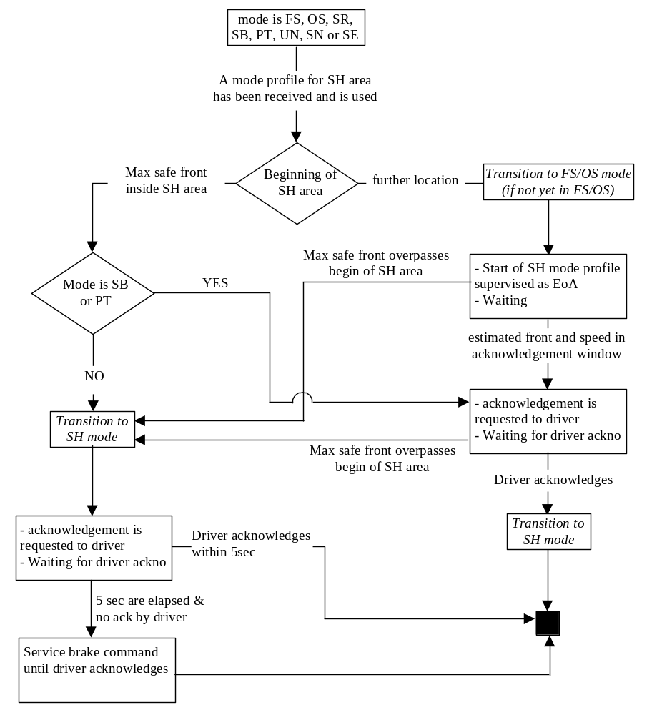

Procedure Override EoA

Introduction

In specific degraded situations (for example in the case of a failed signal, failed track circuit, failed point…), railways allow a train to pass its EoA.

For ERTMS/ETCS, passing an EoA can be required in degraded situations, e.g.
- In level 2/3, if a train is stopped without MA in a location where radio is unavailable (e.g. after having received an emergency message, or after a train trip).
- In level 2/3, if a train is stopped at the border between two adjacent RBCs (e.g. the interface between RBCs is unavailable).
- In level 2/3, if a train is stopped after having passed the border between two adjacent RBCs (e.g. the connection to the Accepting RBC cannot be established).
- In level 2/3, if the RBC is unable to give a permission to run (e.g. lost connection with the interlocking)
- In level 1, if a signal cannot show a proceed aspect (e.g., signal failure, route cannot be set)
- In level 1, if a train is stopped without MA (e.g. after the MA has been shortened due to a time out).

In level 0 areas, overriding the EOA (passing a signal at danger) is only a national procedure. The ERTMS/ETCS on-board equipment is not involved in this procedure, since it does not supervise the train movements.

In ERTMS equipped areas (level 1, 2 or 3), locations where the train shall stop are supervised by the ERTMS/ETCS on-board equipment. Receiving an order from the signalman to pass the EoA, the driver must then be able to inhibit this supervision.

Note: The driver must not use the “Override EOA” procedure unless authorised by trackside personnel. This authorisation is covered by national procedures.

If an EOA must be passed between announcement and execution of the level transition from an unfitted area (level 0) to an ERTMS equipped area (level 1, 2, 3, STM), the signalman is also responsible for giving the order to the driver to select the “override EOA” procedure.

Note: Passing the EoA by using this procedure the driver is fully responsible for the train driving. Therefore Staff Responsible mode is entered when the driver selects “override EOA”.

In addition the procedure allows to avoid a train trip when passing a balise group:
- transmitting "stop in SR mode"
- not contained in the list of expected balises in SR mode
- transmitting "stop in SH mode"
- not contained in the list of expected balises in SH mode"
- overpassing the SR distance (see also 4.4.11.1.4)

Selection of “Override”

The ERTMS/ETCS on-board equipment shall allow the driver to select “Override” (i.e. the “Override” button becomes available) only when:
- The train speed is under the maximum speed limit for triggering the “override EoA” function (national value) AND
- The current mode is Full Supervision, On Sight, Staff Responsible, Shunting, Unfitted, Post Trip, Stand By or STM European/National AND
- Validated Train Data is available (except when already in Shunting mode).

Note: The selection of “Override” should be secured (protected button, or confirmation of selection), but this is not required for the technical interoperability.

The “Override EOA” procedure shall be triggered when selected by the driver.

Once the “Override EOA” procedure has been triggered

The mode shall change as follows:
- If the current mode is Full Supervision, On Sight, Stand-By or Post Trip, the mode shall immediately switch to the Staff Responsible (SR) mode (if the mode is already SR it remains unchanged)
- If the current mode is Shunting the mode shall remain unchanged
- If the current mode is Unfitted (level 0 area) or STM European/National (level STM) the mode shall only change to Staff Responsible when the level changes to 1,2 or 3 (refer to SRS chapter 4, transitions between modes)

If the mode, when activating Override EoA, is OS or FS, the former EoA shall be retained. If the mode is SB or PT, the current position of the train front shall be considered as the former EoA.

Note: This former EoA will be used as a Trip condition if the transition to Trip mode is re-activated. Any further activation of the Override EoA in SR mode has no effect on the former EoA.

If the train passes a balise group giving “Stop if in SR mode” former EoA shall be deleted.

Note 1: In level 2, 3, if radio communication is available, the RBC is only informed that the Override EoA has been triggered by means of the reported mode change (if there is any)

Note 2: In level 2,3, if the ERTMS/ETCS- onboard equipment is able to report the mode change to the RBC, the RBC may transmit limits for the distance to run in SR mode (overriding the national value), a list of balises to be passed in SR mode (refer to chapter 4, Staff Responsible mode)

In level 2,3, if the train is stopped in a location where radio is unavailable, the triggering the “Override EoA” procedure order shall revoke all valid emergency stop orders.

In SR mode the driver may modify the value of the maximum SR speed and the distance to run in SR mode (refer to chapter 4, Staff Responsible mode)

In all levels
- The train trip shall be inhibited (inhibition of the transition to the Trip mode).
- As long as the train trip is suppressed an additional special speed limit (national value) shall be applied

Re-activation of the transition to Trip mode

The inhibition of the transition to Trip mode shall end when at least one of the following conditions is fulfilled:
- The "max. time for train trip suppression when override EoA function is triggered" (national value) is passed, OR
- The train has run more than the "distance for train trip suppression when Override EoA function is triggered" (national value), OR
- The former EoA has been passed with the min safe antenna position (calculated by subtracting distance between active EUROBALISE antenna and the front end of the train from the min safe front end position), OR
- The train passes a balise group giving “stop in SR” or “stop in SH” information, OR
- The train passes a balise group giving proceed information (i.e., MA with no signalling relating speed restriction of value zero)
- In level 2,3, an MA is received from the RBC
- The train passes a balise group not in the list of expected balises in SR mode or the list of expected balises in SH mode
- The train overpasses the SR distance supervised before overriding with its estimated front end.

Note: For modes UN and SE/SN, only re-activation conditions a) and b) are supervised.

Intentionally deleted.

After the transition to Trip mode is re-activated the ERTMS/ETCS on-board equipment shall switch to another mode when the relevant conditions are fulfilled (see SRS - chapter 4, Transition between Modes).

Procedure On-Sight

General Requirements

The ERTMS/ETCS on-board equipment shall be in On Sight mode before the train reaches the beginning of the On Sight area or, at the latest, when the train reaches the beginning of the On Sight area.

An acknowledgement for running in On Sight mode shall be requested from the driver. The conditions of the acknowledgement are specified below.

On Sight is requested for current location (from modes different from Stand By and Post Trip)

In a level 1 area, the beginning of the On Sight area can be the balise (group) that gives the Mode Profile. When the train passes the balise group and receives this information, the ERTMS/ETCS on-board equipment shall immediately switch to On Sight mode.

In a level 2 or 3 area, the ERTMS/ETCS on-board equipment can receive a mode profile giving an On Sight area which the train has already entered with its max safe front end. In this case, the ERTMS/ETCS on-board equipment shall immediately switch to On Sight mode.

The driver must acknowledge the On Sight mode. A request of acknowledgement shall be displayed to the driver.

If the driver has not acknowledged after a 5 seconds delay, the service brake command shall be triggered. The brake command is released when the driver acknowledges, except if brakes are also applied for another reason(s).

Note: Once in On Sight mode, the speed supervision is such that the train speed cannot exceed the OS mode permitted speed limit. If, when entering the On Sight mode, the train speed was higher than the max. OS permitted speed (because a higher speed was allowed in Full Supervision mode or in Staff Responsible mode) then a service/emergency brake command could be immediately triggered, independently of the acknowledgement of the driver, but because of the On Sight supervision (see figure 2).
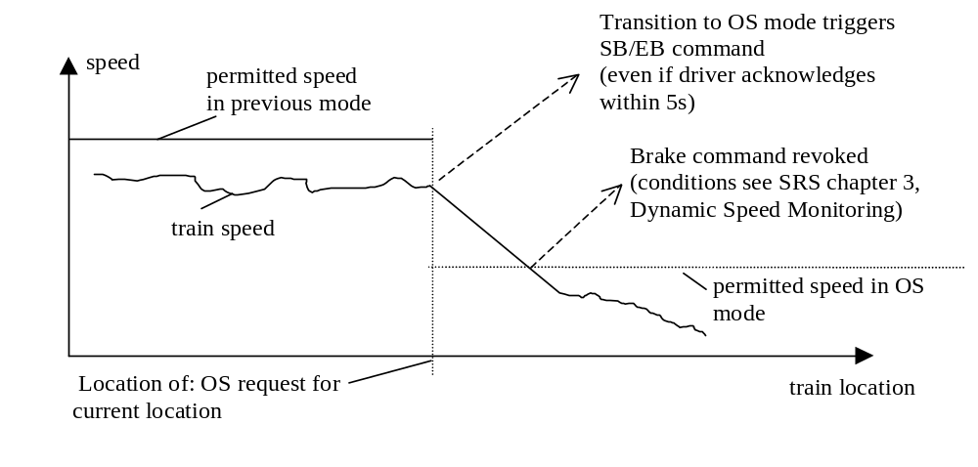
Figure 2. Train enters OS area with too high speed

Note: This sharp brakes reaction can be avoided in Full Supervision mode by giving with the previous MA an EoA (or a LoA = max. OS permitted speed) at the location of transition to On Sight mode. In Staff Responsible mode, lateral signals (if available) can also order the driver to decrease the train speed.

If the ERTMS/ETCS on-board equipment is already in OS mode when receiving the OS mode profile, no further acknowledgement shall be requested from the driver.

On Sight is requested for a further location

The beginning of the On Sight area can be a location that the train has not reached yet. This occurs when:
- In a level 1 area, a balise group gives a Mode Profile with an On Sight area that is located at a further location.
- In a level 2 or 3 area, the RBC gives a Mode Profile with an On Sight area that is located at a further location.

A request for acknowledgement shall be displayed to the driver when the two following conditions are fulfilled:
- The distance between the estimated front end of the train and the beginning of On Sight area is shorter than a value, contained in the mode profile
- The speed is lower than the On Sight mode permitted speed (national value, or value given in the mode profile)

Note: These 2 conditions define the “rectangle of acknowledgement”.

Once the acknowledgement request is displayed, it is not taken back if the train leaves the “rectangle of acknowledgement” (for example: because the train accelerates).

The beginning of the On Sight area shall be supervised like an EoA, no Release Speed shall be used in this case.

When the driver acknowledges the On Sight mode, the ERTMS/ETCS on-board equipment shall immediately switch to the On Sight mode.
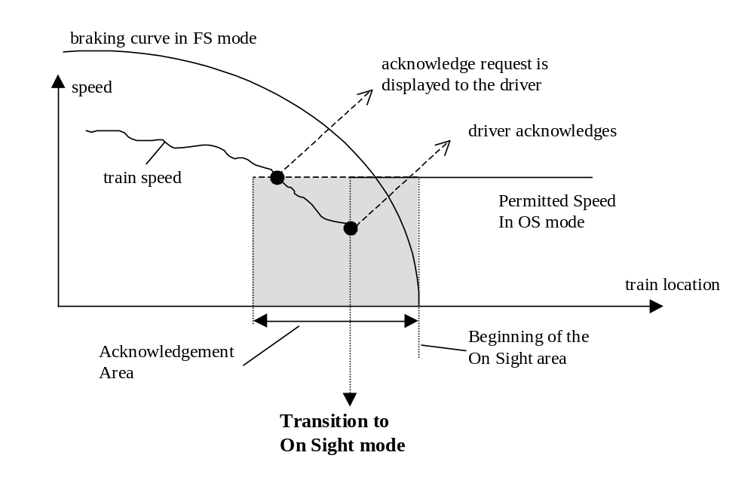
Figure 3. Transition from FS to OS mode after driver acknowledgement

If the max safe front end of the train reaches the beginning of the On Sight area according the mode profile and the driver has not yet acknowledged, the ERTMS/ETCS on-board equipment shall switch immediately to OS mode and a request for acknowledgement shall be displayed to the driver (refer to SRS chapter 4, transitions between modes).

If, in this case, the driver does not acknowledge within 5 sec after the change to OS mode, the service brake command shall be triggered. The command shall be released as soon as the driver acknowledges (unless the command was triggered also for other reasons).

On Sight from Unfitted or STM mode

The mode profile with regards to an OS area is only evaluated in levels 1,2,3, although the mode profile may have been received in level 0 (Unfitted mode) or STM (STM European/National modes). A transition to On Sight mode can therefore earliest occur at a transition of level: from level 0 or STM to level 1 or 2 or 3.

Specifications of chapters 5.9.2 and 5.9.3 about the acknowledgement shall apply here.

On Sight from Stand By or Post Trip mode

When performing a SoM or a Train Trip procedure and when the current level is 2 or 3 area, the ERTMS/ETCS on-board equipment can receive a mode profile giving an On Sight area which the train has already entered with its max safe front end. In this case, the ERTMS/ETCS on-board equipment shall first require an acknowledgement from the driver.

When the driver acknowledges, the ERTMS/ETCS on-board equipment shall perform transition to On Sight mode.”

Figure 4. State chart for OS

Exit of On Sight mode

General rule

The ERTMS/ETCS on-board equipment exits the On Sight mode when the min safe front end of the train passes the end of the On Sight area.

First case: The On Sight area ends at the EOA of the current MA

This occurs when the end of the On Sight area that is given by the Mode Profile has the same location as the EOA of the related MA.

In this case, the train must receive a new Movement Authority to be able to exit the On Sight area.

Another way is to send a MA with a new Mode Profile, that changes the end of On Sight area

5.9.6.2.4 When exiting the On Sight area, the ERTMS/ETCS on-board equipment switches either to Full Supervision or to Shunting mode (refer to SRS chapter 4, transitions between modes).

Second case: The On Sight area ends before the EOA of the current MA

In this case, the current Movement Authority already allows the train to exit the On Sight area.

When exiting the On Sight area, the ERTMS/ETCS on-board equipment switches either to Full Supervision or to Shunting mode (refer to SRS chapter 4, transitions between modes).

Option: In an On Sight area, there is no guarantee for the RBC that the track in front of the supervised train is free. If the next block is free, the RBC can extend the current OS-MA of the train by a FS-MA on the next block ONLY if the RBC has the following information: “there is nothing between the supervised train and the end of the On Sight area”.
- This information can be given to the RBC by the signalman (outside scope of ETCS)
- This information can be inquired by the RBC by means of the following mechanism: the RBC sends a “track ahead free” request that the on-board displays to the driver. If the driver confirms that the track is free up to the end of the current section, the on-board will transmit this information to the RBC.

State diagram
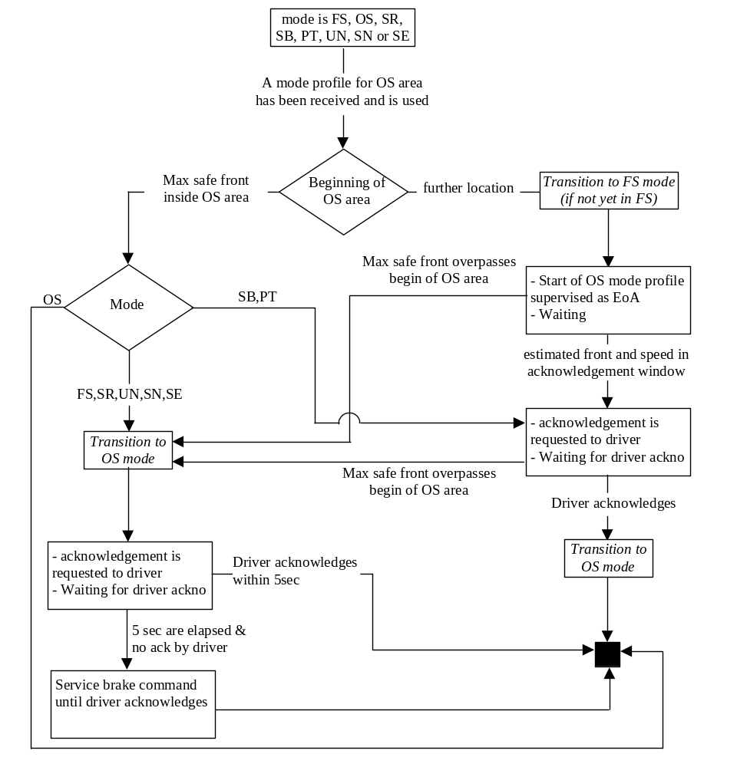

Level Transitions

General requirements

Every level transition border to levels 2, 3, or STM shall be announced to the ERTMS/ETCS on-board equipment via balise group or via the RBC.

A level transition announcement to the ERTMS/ETCS on-board equipment shall consist of an order to execute the level transition at a further location corresponding to the border.

When the ERTMS/ETCS on-board equipment receives a level transition announcement, it shall immediately inform the driver about the announced level transition.

At the level transition border a balise group with an order to switch to the new level immediately shall be placed.

Note: Balise groups are read in all levels and level transition orders from balises are accepted independent of the level of operation. Also sleeping units read balise groups.
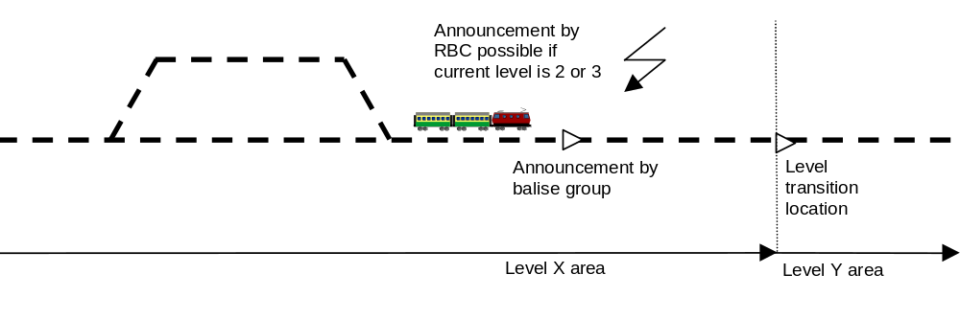
Figure 5. Transition from level X area to level Y area

If the message from the border balise group is not received, the level transition shall still be executed when the estimated front end passes the location given in the announcement.

The on-board equipment shall manage only one level transition order at a time. Therefore a new level transition order shall replace a previously received order, i.e. if a new order to switch to a different level or to the same level but at a different location is received, before the action from the first order has been performed, only the last order shall be executed.

As soon as the announcement of the level transition has been received, some data (mainly movement authority and track description data) from the transmission media of the new level shall be accepted, but shall not be used until the level transition is effective.

Note: for the exhaustive list of accepted/rejected information, please refer to SRS chapter 4.8.

Note: if only track description has been received from the new media without any movement authority, this track description still replaces the one previously received from the current media when the transition is performed.

When the onboard has performed the level transition, further data (mainly movement authority and track description data) received from the transmission media of the level being left shall be rejected.

Note: for the exhaustive list of accepted/rejected information, please refer to SRS chapter 4.8.

The procedure of the level transition shall be cancelled:
- at a change of train orientation (operational requirement, covered by the mode changes involved)
- If the train continues in the same direction and does no longer enter the announced area: new level transition information shall be given to the train confirming the current level.

Requirements for mixed level

Any combination of ERTMS/ETCS levels 0, STM, 1, 2, and 3 on a given area shall be possible.

When going to a mixed level area, the level transition announcement and the level transition order at the border shall contain all the supported ERTMS/ETCS levels with a table of priority.

Note: Level 0 is considered as the other levels. This means that, for example, when an area permits ERTMS/ETCS level 0, and is fitted with ERTMS/ETCS level 1 and 2, the track-side gives a level transition order containing the levels 0,1 and 2 to approaching trains.

The table of priority shall list all the supported levels from the highest priority level to the lowest one.

Examples : table gives 3,2,STM X, 1, STM Y, 0. Train is fitted for level 1 and STM X, it will select STM X level. Train is fitted for level 1 and STM Y, it will select level 1. Train is level 2 fitted, it will select level 2.

When receiving the information about all ERTMS/ETCS levels that are available, the ERTMS/ETCS on-board equipment shall select in the table the level with the highest priority that the onboard equipment allows to use.

When the onboard has selected the level it will switch to, it shall carry out the level transition as if it has received a level transition order to this level only i.e. it shall ignore the requirements related to transitions to the other levels.

The ERTMS/ETCS on-board equipment shall inform the driver only about the selected level transition.

If the ERTMS/ETCS on-board equipment is not fitted for any of the announced levels it shall nevertheless make the transition, to the announced level with the lowest priority.

Justification: The On-board equipment will then indicate the trackside level to the driver to allow him to select the correct procedures for degraded situations.

The ERTMS/ETCS on-board equipment shall store the table of the supported ERTMS/ETCS levels.

At standstill, the onboard equipment shall allow the driver to change the ERTMS/ETCS level amongst those stored in the table of priority (for fallback situations).

If the driver changes the level from 2 or 3 to any other, the ERTMS/ETCS on-board equipment shall report the new level to the RBC if a communication session is established. When receiving the level change report, the RBC shall order the communication session to be terminated.

Note: It is up to the operational rules to define in which situations the driver is allowed to change the level.

Specific Additional Requirements

Transition from Level 1 to Level 2/3 area

An order to connect to the RBC with a given id and telephone number shall be given via balise group in rear of the border location.

For the train to be able to enter the new area, the old area must possess information about at least the first section of the new area. The information may be transmitted to the train either:
- as an MA and track description information into the new area, or
- as a target speed at the border location i.e. as an LOA.

When the ERTMS/ETCS communication session is open, Train Data shall be sent to the RBC (which acknowledges the data) unless the onboard equipment is in sleeping mode.

If no Level 2/3 MA and track description has been received when entering the new area, the train shall still be supervised according to the level 1 MA previously received.

When the ERTMS/ETCS on-board equipment has switched to the new level, it shall report the new on-board level, including a position report.

If an order to connect to an RBC has been received and the train will not enter the announced RBC area, an order to terminate the session shall be sent either from balises or from the RBC for any route not leading to the RBC area. This is the case both if the train turns back and if the train continues in the same direction, but on another route.

Transition from Level 0 (Unfitted) to Level 2/3 area

An order to connect to the RBC with a given id and telephone number shall be given via balise group in rear of the border location.

When the ERTMS/ETCS communication session is open, Train Data shall be sent to the RBC (which acknowledges the data) unless the onboard equipment is in sleeping mode.

A level 2/3 MA and track description information shall be received from the RBC before the level transition border. If not, the train shall be tripped at passage of the border, i.e. after switching to level 2 or 3, movement is not allowed without a movement authority (refer to SRS chapter 4, transitions between modes).

The driver is responsible for entering the level 2/3 area at a speed not exceeding the maximum speed of the unequipped line.

When the ERTMS/ETCS on-board equipment has switched to the new level, it shall report the new on-board level, including a position report.

If an order to connect to an RBC has been received and the train will not enter the announced RBC area, an order to terminate the session shall be sent either from balises or from the RBC for any route not leading to the RBC area. This is the case both if the train turns back and if the train continues in the same direction, but on another route.

Transition from Level 2/3 to Level 1 area

For the train to be able to enter the new area, the old area must possess information about at least the first section of the new area. The information may be transmitted to the train either
- as an MA and track description information into the new area, or
- as a target speed at the border location i.e. as an LOA.

If no Level 1 MA and track description has been received when entering the new area, the train shall still be supervised according to the level 2/3 MA previously received from the RBC.

When the train has passed the level transition border with its full length, i.e. when the whole train has left the level 2/3 area, the onboard equipment of the leading engine shall send a position report to the RBC.

After receiving this exit position report, the RBC can order the train to terminate the session (leading and non-leading engines).

Transition from Level 0 (Unfitted) to Level 1 area

A level 1 MA and track description information shall be received before or at the level transition border. If not, when the level transition is performed, the train shall be tripped, i.e. after switching to level 1, movement is not allowed without a movement authority (refer to SRS chapter 4, transitions between modes).

The driver is responsible for entering the level 1 area at a speed not exceeding the maximum speed of the unequipped line.

Transition from Level 1 to Level 0 (Unfitted) area

For the train to be able to enter the new area, the old area must possess information about at least the first section of the new area. The information may be transmitted to the train either
- as an MA and track description information into the new area, or
- as a target speed at the border location i.e. as an LOA.

Note: When entering UN mode, all MA and track description data is deleted (refer to SRS Chapter 4, What happens to stored data when entering a mode)

Transition from Level 2/3 to Level 0 (Unfitted) area

For the train to be able to enter the new area, the old area must possess information about at least the first section of the new area. The information may be transmitted to the train either
- as an MA and track description information into the new area, or
- as a target speed at the border location i.e. as an LOA.

When the train has passed the level transition border with its full length, i.e. when the whole train has left the level 2/3 area, the onboard equipment of the leading engine shall send a position report to the RBC.

After receiving this exit position report, the RBC can order the train to terminate the session (leading and non-leading engines).

Note: When entering UN mode, all MA and track description data is deleted (refer to SRS Chapter 4, What happens to stored data when entering a mode)

Transition from Level STM to Level 2/3 area

An order to connect to the RBC with a given id and telephone number shall be given via balise group in rear of the border location.

When the ERTMS/ETCS communication session is open, Train Data shall be sent to the RBC (which acknowledges the data) unless the onboard equipment is in sleeping mode.

A level 2/3 MA and track description information shall be received from the RBC before the level transition border. If not, the train shall be tripped at passage of the border, i.e. after switching to level 2 or 3, movement is not allowed without a movement authority (refer to SRS chapter 4, transitions between modes).

The driver is responsible for entering the level 2/3 area at a speed not exceeding the maximum speed of the level STM line.

When the level transition location is passed with the estimated front end a position report shall be sent to the RBC and the active STM shall be set to standby.

If an order to connect to an RBC has been received and the train will not enter the announced RBC area, an order to disconnect shall be sent either from balises or from the RBC for any route not leading to the RBC area. This is the case both if the train turns back and if the train continues in the same direction, but on another route.

Transition from Level STM to Level 1 area

A level 1 MA and track description information shall be received before or at the level transition border. If not, when the level transition is performed, the train shall be tripped, i.e. after switching to level 1, movement is not allowed without a movement authority (refer to SRS chapter 4, transitions between modes).

The driver is responsible for entering the level 1 area at a speed not exceeding the maximum speed of the Level STM line.

When the level transition location is passed with the estimated front end, the active STM shall be set to standby.

Transition from Level 1 to Level STM area

For the train to be able to enter the new area, the old area must possess information about at least the first section of the new area. The information may be transmitted to the train either
- as an MA and track description information into the new area, or
- as a target speed at the border location i.e. as an LOA.

When the announcement is received, a signal shall be sent by the ERTMS/ETCS on-board equipment to the STM specified in the announcement meaning that the STM shall prepare for immediate activation when the level transition location is passed with the estimated front end.

When the level transition location is passed with the estimated front end, the STM specified shall be activated by the ERTMS/ETCS on-board equipment.

Transition from Level 2/3 to Level STM area

For the train to be able to enter the new area, the old area must possess information about at least the first section of the new area. The information may be transmitted to the train either
- as an MA and track description information into the new area, or
- as a target speed at the border location i.e. as an LOA.

When the announcement is received, a signal shall be sent by the ERTMS/ETCS onboard to the STM specified in the announcement meaning that the STM shall prepare for immediate activation when the level transition location is passed with the estimated front end.

When the train has passed the level transition border with its full length, i.e. when the whole train has left the level 2/3 area, the onboard equipment of the leading engine shall send a position report to the RBC.

After receiving this exit position report, the RBC can order the train to terminate the session (leading and non-leading engines).

When the level transition location is passed the STM specified shall be activated.

Transition from Level STM (STM X) to Level STM (STM Y)

When the announcement is received, a signal shall be sent by the ERTMS/ETCS onboard to the STM specified in the announcement meaning that the STM shall prepare for immediate activation when the level transition location is passed with the maximum safe front end.

When the level transition location is passed with the maximum safe front end the active STM (STM X) shall be set to standby and the STM specified in the border balise group (STM Y) shall be activated.

The driver is responsible for entering the new Level STM area (STM Y) at a speed not exceeding the maximum speed of the previous Level STM line (STM X).

Transition from Level STM to Level 0

When the level transition location is passed the active STM shall be set to standby.

The driver is responsible for entering the level 0 area at a speed not exceeding the maximum speed of the Level STM line.

Note: When switching from SE to UN mode, all MA and track description data is deleted (refer to SRS Chapter 4, What happens to stored data when entering a mode).

Transition from Level 0 to Level STM

When the announcement is received, a signal shall be sent by the ERTMS/ETCS onboard to the STM specified in the announcement meaning that the STM shall prepare for immediate activation when the level transition location is passed with the estimated front end.

When the level transition location is passed the STM specified shall be activated.

The driver is responsible for entering the level STM area at a speed not exceeding the maximum speed of the unequipped line.

Conditional level transition order

When the ERTMS/ETCS on-board equipment accepts a conditional level transition order the onboard shall check whether the current level is contained in the priority list of the conditional level transition order.

If the current level is contained in the priority list of the conditional level transition order, the onboard shall not change the level.

If the current level is not contained in the priority list of the conditional level transition order, the onboard shall evaluate the conditional level transition order in the same way as an immediate normal level transition order.

In the same way as for a normal level transition order, the ERTMS/ETCS on-board equipment shall store the table of ERTMS/ETCS levels supported by trackside.

Note: The conditional level transition order allows to check, whether a train operates in a permitted level e.g. following a start of mission after a cold movement. The level of a train driving in a permitted level will not be changed, regardless of the priority of the current level operated by the train.

Acknowledgement of the level transition

If defined so for the level transition (see table below), the driver shall be asked to acknowledge the transition when the max safe front end of the train passes a trackside defined location in rear of the level transition border.

Exception: An ERTMS/ETCS on-board equipment in NL mode shall not require an acknowledgement from the driver.

If the driver has not yet acknowledged 5 seconds after the level transition, a service brake command shall be initiated.

The driver shall then acknowledge the level transition in order to release the service brake command.

For the following transitions marked as “YES”, the level transition announcement shall define the location from where an acknowledgement is required:
 |  | Acknowledgement when entering
 |  | L 0 | L 1 | L 2 | L 3 | STM
Coming from ... | L 0 | - | No | No | No | Yes
Coming from ... | L 1 | Yes | - | No | No | Yes
Coming from ... | L 2 | Yes | No | - | No | Yes
Coming from ... | L 3 | Yes | No | No | - | Yes
Coming from ... | STM | Yes | Yes | Yes | Yes | Yes

Procedure Train Trip

Introduction

A train can be tripped for various reasons: refer to SRS chapter 4, mode transition table.

State transition chart

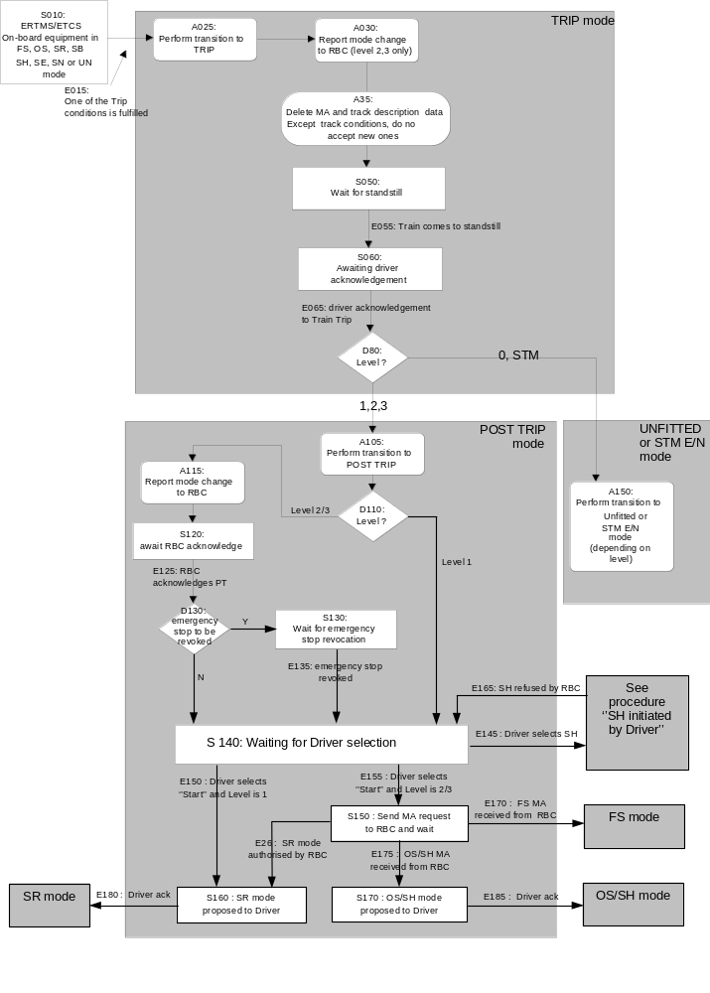
Figure 6. State transition chart for train trip

Explanatory table for state transition chart Train Trip

# | Description | Level
S010 | The ERTMS/ETCS on-board equipment is in one of the following modes: FS, OS, SR, SB, SH, SE, SN or UN | 0,STM, 1,2,3
E015 | An event occurs, which leads to train trip reaction (refer to chapter 4, transitions between modes) | 1,2,3
A025 | The on-board equipment shall switch to TRIP mode. | 1,2,3
A030 | The on-board equipment reports the mode change to the RBC (only if a communication session is open) | 2, 3
A035 | All current MA and track description data, except track conditions, is deleted, accepting new ones inhibited | 1,2,3
S050 | The on-board equipment awaits standstill. While braking a border to a level 0 or STM area may be passed | 0,1,2,3,STM
E055 | The train has come to standstill. | 0,1,2,3, STM
S060 | The on-board equipment shall display the "Request for driver acknowledgement to Train Trip" to the driver | 0,1,2,3, STM
E065 | Driver acknowledges Train Trip | 0,1,2,3, STM
D80 | If the level is 0 or STM, the mode changes to UNFITTED or STM EUROPEAN/ NATIONAL. For levels 1 to 3 the mode changes to POST TRIP | 0,1,2,3,STM
A105 | On entering POST TRIP mode the on-board equipment revokes the emergency brake command.  For the supervision provided by the POST TRIP mode refer to SRS chapter 4) | 1,2,3
A150 | If the mode changes to UNFITTED (level 0) no further supervision with regards to the train trip is provided, if the mode changes to STM EUROPEAN/ NATIONAL (level STM), the supervision with regards to the train trip depends on the active STM. | 0,STM
D110 | What is the current level of operation? | 1,2,3
A115,S120 | If the level is 2 or 3 the mode change to POST TRIP mode shall be reported to the RBC which shall acknowledge the mode report. | 2, 3
E125 | RBC acknowledges Post trip mode | 2,3
D130,S130, E135 | Wait until the RBC revokes ALL pending emergency stops. | 2,3
S140,E145,E150,E155 | The ERTMS/ETCS on-board equipment shall offer the possibility to the driver to select "start" (only if train data has been previously entered), or to select SH  - When the level is 1 and the driver selects "start" (E150), the process shall go to S160  - When the level is 2 or 3 and the driver selects "start" (E155), the process shall go to S150  - If the driver selects SH (E145), the continuation of the procedure is the same as for the procedure “Shunting initiated by the driver” | 1,2,3
S150 | The ERTMS/ETCS on-board equipment shall send an MA request to the RBC and wait.  - If an SR authorisation is received from RBC (E26), the process shall go to S160  - If an MA allowing OS/SH is received from RBC (E175), the process shall go to S170  - If an MA allowing FS is received from RBC (E170), the ERTMS/ETCS on-board equipment shall perform transition to Full Supervision mode (refer to SRS chapter 4, transitions between modes: transition from PT to FS) | 2,3
S160 | The ERTMS/ETCS on-board equipment shall require an acknowledgement from the driver for running in Staff Responsible mode. When the driver acknowledges (E180), the ERTMS/ETCS on-board equipment shall perform transition to SR mode (refer to SRS chapter 4, transitions between modes: transition from PT to SR) | 1,2,3
S170 | The ERTMS/ETCS on-board equipment shall require an acknowledgement from the driver for running in On Sight/Shunting mode . When the driver acknowledges (E185), the ERTMS/ETCS on-board equipment shall perform transition to On Sight/Shunting mode (refer to SRS chapter 4, transitions between modes: transition from PT to OS/SH) | 2,3

Degraded Situations

ERTMS/ETCS level 2 or 3: no acknowledge for PT mode is received from the RBC

In case a communication session is open and no reply is received from the RBC the mode change report shall be repeated a defined number of times (see appendix to chapter 3, List of Fixed Value Data). If not successful the ERTMS/ETCS onboard equipment shall terminate the session and inform the driver.

In case no communication session is open when the mode change is to be reported, no communication session shall be opened, i.e., no report shall be sent and the driver informed.

Nominally, accidental loss of an already open session (that can occur at any step) has not been taken into account for the design of the flowchart. However, should such a fault occur in any step while ERTMS/ETCS on-board equipment is in level 2/3 and in PT mode, the driver shall have the possibility to select "Override" and the process shall go to the procedure "Override EoA"

Change of Train Orientation

Introduction

The scope of this procedure is the supervision of a train having a mission where the driver controls the train from the cab in the front of the train with the direction controller in FORWARD position.

This implies that when the driver has to change the orientation of the train, he has to change the driving cab.

The scope of this procedure is NOT shunting movements, where the driver can change the running direction of the train without leaving the cab, by changing the position of the direction controller from FORWARD to REVERSE.

The scope of this procedure is NOT the backwards movement that is allowed in Post Trip or in Reversing mode.

The driver uses the same engine

The situation is the following: The driver closes the desk A and leaves the cab A of the leading engine of the train, to go to cab B and open desk B of this same engine.

Desk A and desk B are connected to the same ERTMS/ETCS on-board equipment.

When the driver closes the desk A, the ERTMS/ETCS on-board equipment shall immediately go to Stand-By mode. If the train has a mission, this is an end of mission (see “End of Mission” procedure)

When the driver opens the desk B, the “Start of Mission” procedure is triggered.

When the driver closes a desk and opens the other one of the same engine, the ERTMS/ETCS on-board equipment shall be able to calculate the new train position data (train front position, train orientation), by use of the previous data.

The driver leaves the engine to go to another one

The described situation is the following: The train has two engines (engine A and engine B). The engine A is the leading engine. The engine B is a slave engine. Each engine has its own ERTMS/ETCS on-board equipment.
- If engine B is remote controlled, its ETCS on-board equipment is in Sleeping mode.
Note: The mode is entered when on-board equipment detects the presence of the "remote control" signal.
- If the slave engine is not remote controlled (Tandem operation) by the leading engine but there is a driver who controls the engine, then the on-board equipment is in Non leading mode.

Assumption: The train configuration does not change.
- When changing the train orientation, the leading engine A will become the slave engine, and the slave engine B will become the leading engine.
- If before the change of train orientation engine B was in SL, afterwards engine A will be in SL mode; If before the change of train orientation engine B was in NL, afterwards engine A will be in NL mode.

Case "Engine B was in SL mode"

The driver of engine A closes the desk, then the ERTMS/ETCS on-board equipment of engine A switches to Stand-By mode. If the train has a mission, this is a end of mission (see “End of Mission” procedure)

As soon as the remote control signal disappears, the ERTMS/ETCS on-board equipment of engine B switches to Stand-By mode.

Level 2,3: The ERTMS/ETCS on-board equipment shall open a communication session (if possible) and report the mode change to the RBC.

When the driver opens a desk of engine B he triggers the "Start of Mission" procedure.

Case "Engine B was in NL mode"

The driver of engine A selects "Non Leading". The ERTMS/ETCS equipment switches to Non Leading mode.

The driver of engine B selects "End of Non Leading". The ERTMS/ETCS on-board equipment switches to Stand-By mode (see “End of Mission” procedure).

Because the desk is open, when the ERTMS/ETCS on-board equipment enters Stand-By mode, the “Start of Mission” procedure is triggered.

Train Reversing

This procedure is intended to allow the fast reversal of movement of a train, to run away from a danger up to a “safe” location.

The area where initiation of reversing shall be possible shall be announced to the ERTMS/ETCS on-board equipment, with a message, indicating its start and end and permitted distance to run and maximum speed, after switching to RV mode.

While the train is at standstill inside the reversing permitted area, the driver shall be informed that reversing is possible

If the driver chooses to reverse, the ERTMS/ETCS on-board equipment shall ask for a confirmation

If the driver confirms, the on-board equipment shall switch to RV mode

It shall be possible for the RBC to send a new distance to run.

Joining / Splitting

Definitions

Definition for splitting: The “train to be split” is the train at standstill, waiting for being split. The “front train after splitting” refers to the front part of the train before splitting, the “new train after splitting”, refers to the other part.

Definitions for joining: The “train to be joined” is the train at standstill, waiting for being joined. The “joining train” is the train performing the joining operation.

Procedure “Splitting”

Step 1 - The electrical and mechanical links between the two trains must be removed (this is a national operational procedure, out of the scope of the SRS).

Step 2a - If the ERTMS/ETCS onboard equipment which was supervising the train before splitting has not performed an end of mission for splitting, the driver must modify the Train Data such that it fits with the new train length after splitting.
For level 2 or 3, the new train data is sent to the RBC (see SRS chapter 3 – Data Entry / Modification Process)

Step 2b - If an ERTMS/ETCS on-board equipment of the "new train after splitting" was in SL mode before, it will switch to SB mode once the remote control signal is not received any more (refer to SRS chapter 4, transitions between modes).
For Level 2 or 3: The ERTMS/ETCS on-board equipment shall open a communication session (if possible) and report the mode change to the RBC.

Step - 2c If an ERTMS/ETCS on-board equipment of the "new train after splitting" was in NL mode before, its driver has to select "end of NL" if it becomes the leading equipment. The ERTM/ETCS on-board equipment will switch to SB mode (refer to “end of mission” procedure).

The driver can then start a new mission with this “new train after splitting” (refer to the “Start of Mission” procedure). In all cases, to start a mission is not the only possibility. Shunting movements, or not moving the new train at all, are also possible.

Procedure “Joining”

Step 1 – The “joining train” must approach the “train to be joined”. This can be performed in SR, OS or SH mode (depending on the information available, and on the national procedure for joining).

Step 2 – The electrical and mechanical links between the two trains must be closed (vehicle dependent, outside the scope of the ETCS).

Step 3a – If a former leading ERTMS/ETCS on-board equipment remains leading and there was no end of mission, the driver must modify the Train Data such that it fits with the new train composition. For level 2 or 3, the new train data is sent to the RBC (see SRS chapter 3 – Data Entry / Modification Process)

Step 3b – If a leading master ERTMS/ETCS on-board equipment is to become slave equipment in SL mode, when closing the desk, the ERTMS/ETCS on-board equipment will switch to SB mode (see SRS chapter 4, transitions between modes) and the end of mission procedure is executed (see “End of Mission” procedure). Transition to SL mode is from SB mode.

Step 3c : If a former master ERTMS/ETCS on-board equipment is to become slave equipment in NL mode, the driver selects NL mode (see SRS chapter 4, transitions between modes).

For further steps after joining refer to procedures “Start of Mission” and “Change of Train Orientation”.

RBC/RBC Handover

Principles

Every RBC/RBC handover shall be announced to the ERTMS/ETCS on-board equipment via a balise group or via the RBC.

The handover announcement to the ERTMS/ETCS on-board equipment shall consist of an order to contact the Accepting RBC and to execute the handover at a further location corresponding to the border.

.At the RBC/RBC border a balise group with an order to execute the handover immediately shall be placed.

Note: Balise groups are read in all levels and orders from balise groups are accepted independent of the level of operation. Also sleeping units read balise groups.

If the message from the border balise group is not (yet) received, the handover shall still be executed when the train with its max safe front end passes the border location according to the announcement information.

Case 1: Two communication sessions can be handled simultaneously

Overview

In the normal operation, the main functional steps needed for running from one RBC area to another one are the following:
- Pre-announcement of the transition by the “Handing Over” RBC;
- Establishment of the radio communication session with the “Accepting” RBC;
- Generation of movement authorities including the border;
- Announcement of the RBC transition
- Transfer of train supervision to the “Accepting” RBC;
- Termination of the session with “Handing Over” RBC.

Step by step description

Pre-announcement

When the “Handing Over” RBC generates a movement authority which reaches the border to another RBC area, it initiates the processes associated to the transition.

The “Handing Over” RBC informs the on-board equipment and the “Accepting” RBC about the RBC/RBC handover.

Establishment of the radio communication session with “Accepting” RBC

A radio communication session with the Accepting RBC is opened by the on-board equipment based on the RBC transition order received from the “Handing Over” RBC (refer to chapter 3, section "management of radio communication").

Generation of MAs including the border

The “Handing Over” RBC is responsible for establishing the movement authority based on:
- Information from the trackside equipment and interlocking of its own area (for the part of route related information up to the border),
- Information from the “Accepting RBC” for the part of route related information in advance of the border.
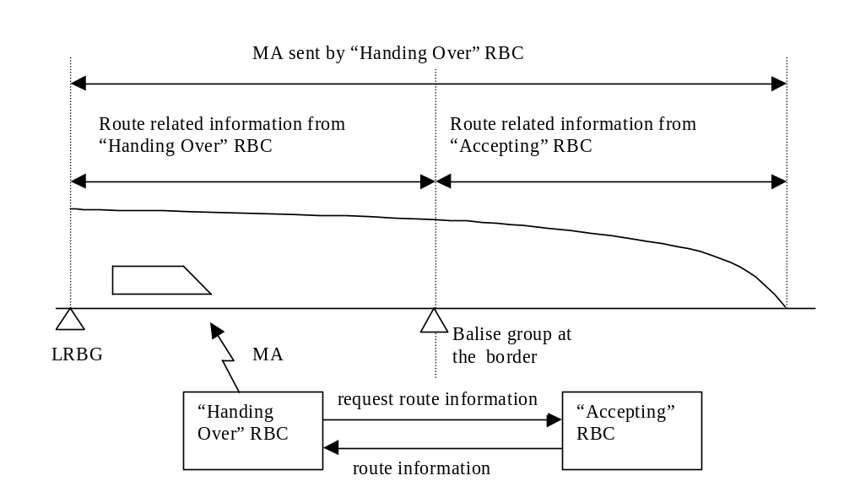
Figure 7: RBC to RBC transition: MA generation.

When it is required to send a movement authority to the train, the “Handing Over” RBC will request from the “Accepting” RBC information needed for extending the MA in advance of the border.

Announcement

When the train reaches the border with its max safe front end, the ERTMS/ETCS on-board equipment sends a position report both to the “Handing Over” RBC and to the “Accepting” RBC.

The “Handing Over” RBC forwards this position report to the “Accepting” RBC.

Note: Although not required for the case of two communication sessions, the forwarding of the position report is executed because the “Handing Over” RBC has no knowledge if the ERTMS/ETCS on-board equipment can handle one or two communication sessions.

Transfer of train supervision to “Accepting” RBC

As soon as the on-board has sent to the “Accepting” RBC the position report, it considers to be supervised by the “Accepting” RBC i.e. it uses information received from the “Accepting” RBC.

When the “Accepting” RBC receives a position report from the on-board and detects that the max safe front end has passed the border, it takes over the responsibility and informs the “Handing Over” RBC.

Termination of the session with “Handing Over” RBC

When the min safe rear end of the train passes the location of the border, the ERTMS/ETCS on-board equipment sends a position report to the “Handing Over” RBC.

When this position report is received by the ”Handing Over” RBC, it sends an order to terminate the session to the ERTMS/ETCS on-board equipment.

Case 2: Only one communication session can be handled

Overview

In this case, the main functional steps needed for running from one RBC area to another one are the following:
- Pre-announcement of the transition by the “Handing Over” RBC;
- Generation of movement authorities including the border;
- Announcement of the RBC transition
- Termination of the session with “Handing Over” RBC;
- Establishment of the radio communication session with the “Accepting” RBC;
- Transfer of train supervision to the “Accepting” RBC.

Step by step description

Pre-announcement

When the “Handing over” RBC generates a movement authority which reaches the border to another RBC area, it initiates the processes associated to the transition.

The “Handing Over” RBC informs the on-board equipment and the “Accepting” RBC about the RBC/RBC transition.

Generation of MAs including the border

The “Handing Over” RBC is responsible for establishing the movement authority based on (see figure 7)
- Information from the trackside equipment and interlocking of its own area (for the part of route related information up to the border),
- Information from the “Accepting RBC” for the part of route related information in advance of the border.

When it is required to send a movement authority to the train, the "Handing Over" RBC will request from the "Accepting RBC" information needed for extending the MA in advance of the border.

Announcement

When the train with its max safe front end reaches the border, the ERTMS/ETCS on-board equipment sends a position report to the “Handing Over” RBC.

The “Handing Over” RBC forwards this position report to the “Accepting” RBC.

Termination of the session with “Handing Over” RBC

As requested by the RBC transition order, when the min safe rear end of the train passes the location of the border, the on-board equipment sends a position report to the “Handing Over” RBC.

When this position report is received by the “Handing Over” RBC, it sends an order to terminate the session to the ERTMS/ETCS on-board equipment.

Establishment of the radio communication session with “Accepting” RBC

When the ERTMS/ETCS on-board equipment receives the session termination order from the “Handing Over” RBC, it terminates the session with the “Handing over” RBC and opens a session with the “Accepting” RBC (refer to chapter 3, management of radio communication).

Transfer of train supervision to “Accepting” RBC

When the ERTMS/ETCS on-board equipment has established a communication session with the “Accepting” RBC and sent to the “Accepting” RBC a position report, it considers to be supervised by the “Accepting” RBC, i.e. it accepts only information received from the “Accepting” RBC.

When the “Accepting” RBC receives a position report from the on-board and detects that the max safe front end has passed the border, it takes over the responsibility and informs the “Handing Over” RBC.

Degraded Situations

If the “Handing Over” RBC is not able to extend the MA into the area of the “Accepting RBC”, the “Override EoA” procedure shall be applied to move the train into the area of the “Accepting RBC”.

If the ERTMS/ETCS on-board equipment cannot open a session with the “Accepting RBC”, the train is stopped when it has reached the EoA given by the “Handing Over” RBC. For passing the EoA the “Override EoA” procedure shall be applied.

If the ERTMS/ETCS on-board equipment is not able to terminate the session with the “Handing Over” RBC: In case no request to terminate the session is received from the RBC but a communication session is open, the position report shall be repeated a defined number of times (see appendix to chapter 3, List of Fixed Value Data). If not successful the ERTMS/ETCS onboard equipment shall terminate the session.

